AI Use in Assignment Development: Checklist for Group Assignment

Artificial Intelligence: A Guide for Students - Research Guides at Thompson Rivers University Library can be accessed via this link
https://libguides.tru.ca/artificialintelligence/home

Please review each section and respond to the questions. If your group answers “Yes” to any item, please elaborate on how AI was used, which tools were involved, and how it influenced your assignment development.

Planning and Research
- Did your group use AI tools to brainstorm or generate topic ideas?
If yes, please describe the tools used and how they shaped your topic selection.
No
- Did your group use AI to summarize or explain academic sources?
If yes, explain which sources were processed and how AI helped with comprehension.
No
- Did your group rely on AI to find or recommend sources or references?
If yes, specify the tools and how they influenced your research direction.
No

Writing and Drafting
- Did your group use AI to generate any part of the written content (for example, paragraphs, summaries, outlines)?
If yes, indicate which sections were AI-generated and how they were integrated.
We used AI to condense our prewritten material to a more podcast-friendly format to allow us to stay within the ten-minute time limits. Note: Please see the original rough draft for reference on pre-AI written material.
- Did your group use AI to rephrase or improve writing (for example, grammar, tone, clarity)?
If yes, describe the extent of revisions and the tools used.
No
- Did your group use AI to translate content from another language?
If yes, mention the original language and the translation tool used.
No

Data and Analysis
- Did your group use AI to analyze data or generate visualizations (for example, charts, graphs)?
If yes, explain the type of data and how AI contributed to the analysis.
No

Creative and Visual Work
- Did your group use AI to create images, diagrams, or design elements?
If yes, specify the tools and the purpose of the visuals.
No
- Did your group use AI to generate code or scripts for interactive or digital components?
If yes, explain the functionality and how it was implemented.
Yes, as described above, we used AI to condense our prewritten material into a more podcast-friendly format to stay within the ten-minute time limit. Note: Please see the original rough draft for reference on pre-AI written material.

Critical Thinking and Originality
- Did your group critically evaluate and revise AI-generated content before including it?
If yes, describe your revision process and how you ensured originality.
Yes, we critically evaluated our revised AI-generated podcast-friendly script before including it by carefully reading through each part and ensuring it accurately reflected our research and writing from our rough draft collectively as a group.
- Did your group ensure that the final submission reflects your own understanding and voice?
If yes, explain how you balanced AI assistance with personal input.
No

Please note below is our uncondensed version of our script prior to AI.

Group Name: What the Patho?
Members: Jade, Richard, Rupert, and Caitlin
Creative Commons License: C 2025. This work is openly licensed via CC BY 4.0

Introduction: Speakers: Cate and Jade
Caitlin: Hello, everyone, we are What the Patho?! I’m Caitlin, and my other groupmates are Jade, Richard, and Rupert. Today, we will explore drug allergies, a type of hypersensitivity that occurs in the body, causing symptoms ranging from mild to severe

Jade: We will also delve into an interesting clinical case study that relates to our topic of drug allergies. As we are discussing a clinical case study, we would like to acknowledge that this video is licensed under C 2025. This work is openly licensed via CC BY 4.0

Explanation of Pathophysiology and relation to other conditions
- What is a drug allergy Richard: Before we get into the details, let’s talk about what a drug allergy actually is. A lot of people say they’re “allergic” to a drug when it’s really just a side effect, but a true drug allergy is when the immune system mistakes a medication for something harmful and overreacts.
Before we get into the details, let’s talk about what a drug allergy actually is. A lot of people say they’re “allergic” to a drug when it’s really just a side effect, but a true drug allergy happens when the immune system mistakes a medication for something harmful and overreacts.
Here’s what’s going on inside the body. When the drug enters the system, it can attach to the body’s own proteins and form what’s called a hapten–protein complex. The immune system sees that complex as a threat and activates antigen-presenting cells, T-helper cells, and B cells, which make IgE antibodies against that drug (Thomson et al., 2022).

Those IgE antibodies attach to mast cells and basophils, priming them for attack. The next time the person takes that same drug, those cells burst open or degranulate releasing histamine, prostaglandins, and leukotrienes. That’s what causes the swelling, hives, wheezing, and anaphylaxis we see in a reaction (Vultaggio et al., 2020).

These reactions are grouped into four hypersensitivity types. The most common, Type I, is the fast IgE-mediated one that can be life-threatening. Type II and III involve antibodies damaging tissues or forming immune complexes, and Type IV reactions happen more slowly, often causing rashes or inflammation days later (Thomson et al., 2022).

Another key idea is cross-reactivity. Sometimes the immune system can’t tell similar drugs apart. For example, people allergic to penicillin might also react to certain cephalosporins, because the two drugs share a similar chemical structure. The immune system just sees a familiar shape and attacks again.
So overall, a drug allergy is really an immune overreaction, sometimes immediate, sometimes delayed, but always involving the body treating medicine like an enemy.

Common drug allergies noted: Speakers: Rupert
When we talk about common drug allergies, the first one that comes to mind is penicillin. It’s one of the most used antibiotics, and also one of the most likely to cause an allergic reaction. Reactions can range from mild rashes or hives to more serious symptoms like swelling, wheezing, or even anaphylaxis.
But here’s something many people don’t realize, not everyone who says they’re allergic to penicillin actually is.
Sometimes it was a childhood rash or side effect, not a true allergy. That’s why testing and reassessment are necessary before avoiding all antibiotics in that family.
Other drugs that often cause allergic reactions include sulfa drugs (like certain antibiotics and diuretics), NSAIDs such as ibuprofen or naproxen, and anticonvulsants used for seizures.
Some people also react to iodinated contrast dyes used in scans, which can cause hives or breathing trouble soon after injection.
As nurses, it’s essential to ask detailed questions about the specific drug, the reaction that occurred, and how soon after taking it. That helps us know whether it’s a true allergy and guides safe medication choices in the future.

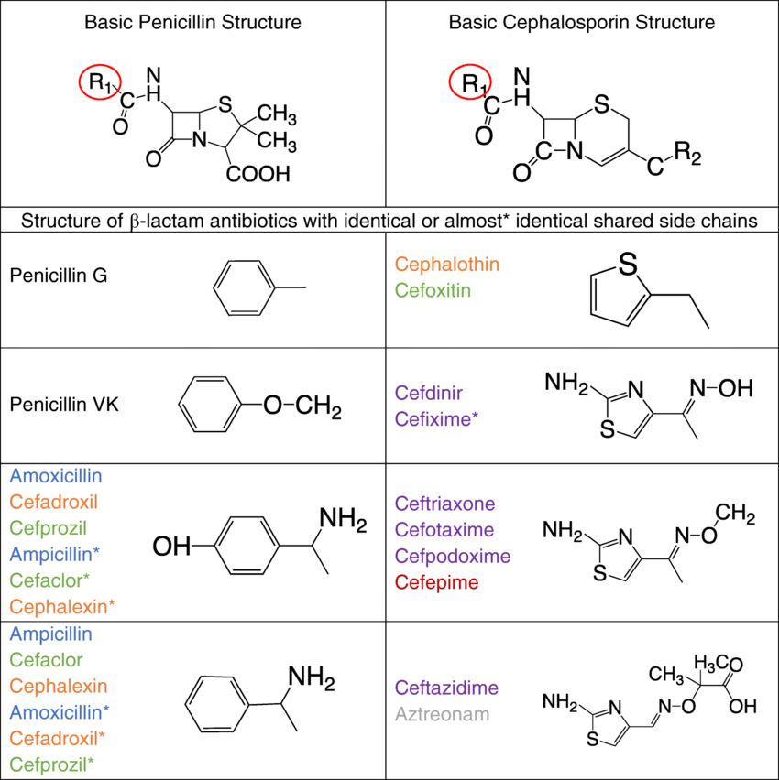
Figure 1. R1 is where IgE-mediated cross-reactivity between penicillins and cephalosporins occurs.

Risk Factors: Speakers: Caitlin and Jade
So, who is typically more at risk of developing a drug allergy? We see it occurring more in young to middle-aged adults (Jeimy et al., 2025). The way the drug is administered also plays a part. When receiving a drug through an intramuscular injection, topical agents, or through an IV, tend to cause more drug reactions than drugs that are given orally (Jeimy et al., 2025). And if we dive even deeper into this, the structuring of the drug impacts this as well. If a drug is protein-based, such as the common antibiotic Penicillin, this can trigger a significantly larger reaction from our immune system than other drugs. We would also like to address the fact that genetic abnormalities, such as HLA gene variations, and conditions like Epstein-Barr virus, significantly increase the risk for individuals compared to those who do not have these conditions (Jeimy et al., 2025).

JADE Something really interesting in newer research is how much our genes can change how we react to medication. Some people have small differences in their CYP450 enzymes, for those who didn’t understand that, those enzymes are the ones that break down drugs, so their bodies process medicine either too slowly or too fast. That can leave too much of the drug in the system and trigger a hypersensitivity or even a toxic reaction (Wittwer et al., 2025). And it’s not just enzymes. Certain HLA genes can make the immune system treat a drug like it’s dangerous. The drug binds to an HLA molecule, activates T-cells, and starts an allergic chain reaction (Thomson et al., 2022; Masmoudi et al., 2022). Studies show this happens more often in older adults, women, and people on multiple medications.
Chronic illnesses also make a big difference. When someone has diabetes, kidney disease, or chronic sinus infections, the body doesn’t clear drugs as fast (Ateş & Şahiner, 2022). The molecules that are leftover can stick to proteins and form hapten–protein complexes, this confuses the immune system into thinking they’re bad invaders. That then kicks off T-helper cells, B-cells, and IgE antibodies that attach to mast cells, and when those cells burst and die, you get histamine release, swelling, hives, and all the classic allergy symptoms.

And finally there’s family history (thanks mom and dad) or having asthma or eczema. These patients already have higher IgE levels, so their immune systems are basically on standby,just waiting to overreact and be drama queen. When they meet a new drug, Th2 cells release messengers like IL-4 and IL-13, which tell B-cells to make even more IgE, which we now know they don’t need more of. That’s why atopic people often have stronger and faster Type I allergic reactions, their immune systems are unfortunately already primed for it.

Clinical Case Study: Speakers: Rupert
Let’s look at a quick case example.
Sarah is 28 and was started on IV ampicillin-sulbactam for an infection. About fifteen minutes into the infusion, she says her lips feel tingly, she starts to itch, and red hives spread across her arms. Suddenly, she’s short of breath and her blood pressure drops, this is anaphylaxis, a severe allergic reaction.
As nurses, we stop the medication right away, call for help, and give epinephrine in the thigh as ordered. We keep monitoring her breathing, give oxygen, and prepare for IV fluids. Once she’s stable, we document everything carefully, what drug was given, what time the reaction started, and what actions were taken.
Before discharge, we remind Sarah to carry an EpiPen, wear a Medic-Alert bracelet, and tell every healthcare provider about her allergy. Education and clear documentation are key to keeping her safe in the future.

Description of Signs and Symptoms: Speakers: Caitlin
Typically, when we see a patient who is experiencing a drug allergy reaction, they may experience a vast range of symptoms. For drug allergies, though, these symptoms are mainly associated with IgE-mediated responses (Warrington et al., 2018). These signs and symptoms can begin quickly, within minutes to an hour, including bronchial muscle spasms, hives on the skin, angioedema (swelling of the lips, hands, or face), wheezing, difficulty breathing, a drop in blood pressure, and anaphylaxis (Warrington et al., 2018). If we are specifically discussing our clinical case study, this drug allergy can be classified as IgE-mediated, IgG-mediated, or IgM-mediated (Warrington et al., 2018). Therefore, symptoms can appear days to weeks after the exposure, which can present as serum sickness, anemia, Stevens-Johnson syndrome, Drug reaction with eosinophilia and systemic symptoms, or DRESS for short (Warrington et al., 2018). Lastly, it can affect our kidneys, leading to kidney disease, also known as nephritis (Warrington et al., 2018).
Diagnostic Evaluations: Speakers: Cate
When a doctor is trying to figure out if someone has a drug allergy, there isn’t just one test or one right answer. Instead, it starts with something pretty simple: a conversation. They’ll ask about the patient’s health history, what medications they’re taking, prescription or non-prescription, how often they take them, and what symptoms they experienced. All of that helps narrow down which medication might be causing the allergy (Jeimy et al., 2025).
From there, doctors have a few different testing options.
One of the most common is the skin prick test. It introduces a tiny amount of the suspected drug into the skin to see if it causes a reaction (Jeimy et al., 2025). If a patient has ever had anaphylaxis to that drug, the test is contraindicated, because even a small amount could be dangerous (Jeimy et al., 2025).
Another tool is patch testing. In this case, the allergen is applied to the skin and covered with a small aluminum disc for about 48 hours (Jeimy et al., 2025). After that, the patch is removed and the skin is checked for irritation or inflammation (Jeimy et al., 2025).
There’s also blood testing, which can help identify drug allergies (Jeimy et al., 2025). However, it’s not always perfect, especially for people with multiple allergies or weakened immune systems like older adults (Jeimy et al., 2025).
In the end, getting the diagnosis right is important. It helps the patient avoid future reactions, find safer medication options, and manage their health with confidence (Jeimy et al., 2025).

Available Treatment: Speakers: Rupert
When it comes to treating drug allergies, what nurses do can truly make the difference.
First, if a patient shows signs of an allergic reaction, such as hives, swelling, or trouble breathing, we act quickly. Stop the drug, stay with the patient, and call for help. The priority treatment is epinephrine, it’s given right away in the outer thigh for anaphylaxis. We then ensure the patient has oxygen and IV access, and continue to monitor their airway, breathing, and circulation.
After the emergency, nurses teach patients how to use an EpiPen, and we document everything clearly, including the specific drug used, the incident, and the treatment administered. We also remind them to wear an allergy bracelet, tell every healthcare provider about it, and keep it listed in their chart.
So, it’s all about quick recognition, immediate action, and strong patient education to keep them safe next time
Jade: Another treatment option is something that may seem a bit daunting to some but is actually quite effective if it is done correctly. This treatment is called drug desensitisation. Now what the heck does this mean? Well, In simple terms this means to retrain the immune system to stop overreacting or in other words taming a diva. Okay, now this is how it works. The patient is given small doses that are increased slowly over time while being closely monitored (Vultaggio et al., 2020). With each small dose the patient is given, gives their immune system time to rewire and adjust to the drug instead of going off the rails and overreacting. This process keeps mast cells and basophils from releasing large amounts of histamine and other inflammatory chemicals at the same time. Over time, the immune response will take a chill pill. The body starts producing more regulatory signals and shifts from that high-alert, IgE-driven, craziness state into a more balanced and peaceful one (Vultaggio et al., 2020). In simpler terms, the immune system becomes more accepting of its new fate, but just enough to let treatment continue safely. It’s important to remember this tolerance is only a temporary effect. If a dose is ever skipped or given incorrectly, the immune system can do a 360 and just reset, and then the reaction risk returns and then we are square one again. That’s why if this desensitization method is being used it must always happen in a hospital setting, with detailed documentation and clear communication between the care team and the patient.

Pt Education: Speakers: JADE
Patient education is one of the most important parts of nursing care and it can honestly save lives. After someone’s had a drug allergy, we make sure they understand what happened, how to recognize it early, and what to do next time. We teach patients to look for early signs like itching, swelling, hives, or shortness of breath, and to treat even mild symptoms seriously (Harig et al., 2018). They also need to know how to use an EpiPen, taking off the blue cap, pressing it into the outer thigh, holding it for ten seconds, and when to call for help. We even encourage family or coworkers to learn how to use one too. Another major point is documentation and communication. We double-check their chart, allergy band, and pharmacy file, because errors happen when allergy information isn’t updated (Quan et al., 2023). A Medic-Alert bracelet or a wallet sized card is recommended for patients who have severe allergies with the identified allergens and reaction types listed, so we know what not to give you. Finally, we suggest making a consultation with an allergist for testing or desensitization options as they do specialize in this department. Studies show that continuing education after discharge improves safety and helps prevent further reactions (Lucas et al., 2025). Understanding their allergy is just as important as treating it and our role is to give patients the knowledge and confidence to protect themselves.
Harig, A., Rybarczyk, A., Benedetti, A., & Zimmerman, J. (2018). Clarification of drug allergy information using a standardized drug-allergy questionnaire and interview. Hospital Pharmacy, 53(9), 610–616. https://www.ncbi.nlm.nih.gov/pmc/articles/PMC6065492/

Quan, P. L., Sánchez-Fernández, S., Parrado Gil, L., et al. (2023). Usefulness of drug allergy alert systems: Present and future. Current Treatment Options in Allergy, 10, 413–427. https://doi.org/10.1007/s40521-023-00351-8

Lucas, M., et al. (2025). Impact of a drug allergy education course for non-specialists. Allergy.https://doi.org/10.1111/all.16270

Conclusion: Speakers:

Richard: So, to wrap up this podcast, drug allergies are more than just side effects. They’re complex immune system overreactions that can range from mild hives to life-threatening anaphylaxis.

Jade: We learned that it all starts at the cellular level, where drugs form hapten–protein complexes, setting off a chain reaction with IgE antibodies, mast cells, and histamine release. This explains why symptoms can appear so suddenly and why quick nursing action is so critical.

Cate: We also talked about risk factors, like genetics, chronic illness, and previous reactions, and how drug desensitization can help retrain the immune system when no other treatment options exist.

Rupert: Our case study showed how fast things can change, but also how effective teamwork, epinephrine, and patient education can save lives.

Richard: As nurses, we’re not just giving medications we’re assessing, educating, and advocating for safety. Understanding pathophysiology helps us predict who’s at risk, respond faster, and teach patients how to stay safe long after they leave our care.
Jade: Thanks for tuning in to What the Patho?! We hope you learned something new about drug allergies and the important role nurses play in preventing and managing them.
References:

Ateş, H., & Şahiner, E. S. (2022). Frequency of drug allergy and associated factors reported by patients applying to the internal medicine outpatient clinic. Lokman Hekim Health Sciences, 2(3), 136–141. https://doi.org/10.14744/lhhs.2022.70004
Jeimy, S., Wong, T., Ben-Shoshan, M., Copaescu, A. M., Isabwe, G. A. C., & Ellis, A. K. (2025). Drug allergy. Allergy, asthma, and clinical immunology : official journal of the Canadian Society of Allergy and Clinical Immunology, 20(Suppl 3), 78. https://doi.org/10.1186/s13223-024-00936-1

Kang SY, Seo J, Kang HR. Desensitization for the prevention of drug hypersensitivity reactions. Korean J Intern Med. 2022 Feb;37(2):261-270. doi: 10.3904/kjim.2021.438
Khan, D. A., Banerji, A., Blumenthal, K. G., Phillips, E. J., & Solensky, R. (2022). Penicillin allergy: A 2022 practice parameter update. Journal of Allergy and Clinical Immunology, 149(3), 813-830. https://doi.org/10.1016/j.jaci.2021.12.009
Masmoudi, H. C., Afify, N., Alnaqbi, H., Alhalwachi, Z., Tay, G. K., & Alsafar, H. (2022). HLA pharmacogenetic markers of drug hypersensitivity from the perspective of the populations of the Greater Middle East. Pharmacogenomics, 23(12), 695-708. https://doi.org/10.2217/pgs-2022-0078
Phillips, E. J., Mallal, S. A., & Chung, W. H. (2018). Genetic risk factors for severe cutaneous adverse drug reactions. Journal of Allergy and Clinical Immunology: In Practice, 6(5), 1161-1171. https://doi.org/10.1016/j.jaip.2018.03.002
Romano, A., Atanaskovic-Markovic, M., Barbaud, A., Bircher, A., Brockow, K., & Caubet, J.-C. (2019). NSAID hypersensitivity. Allergy, 74(4), 676-691. https://doi.org/10.1111/all.13667
Shah, R., Brüggen, M. C., Calle, A. S., & Wang, C. W. (2024). Current management of severe cutaneous adverse drug reactions: DRESS, SJS, and TEN. Clinical Reviews in Allergy & Immunology, 66(3), 375-389. https://doi.org/10.1007/s12016-023-08974-x
Thomson, P., Hammond, S., & Naisbitt, D. J. (2022). Pathology of drug hypersensitivity reactions and mechanisms of immune tolerance. Clinical & Experimental Allergy, 52(12), 1379-1390. https://doi.org/10.1111/cea.14235
Vultaggio, A., Matucci, A., Nencini, F., Bormioli, S., Vivarelli, E., & Maggi, E. (2020). Mechanisms of drug desensitization: Not only mast cells. Frontiers in Pharmacology, 11, 590991. https://doi.org/10.3389/fphar.2020.590991
Wang, Y., et al. (2024). Prevention and management of hypersensitivity reactions to iodinated contrast media: A consensus update. Radiology, 311(2), e230154. https://doi.org/10.1148/radiol.230154
Warrington, R., Silviu-Dan, F. & Wong, T. Drug allergy. Allergy Asthma Clin Immunol 14 (Suppl 2), 60 (2018). https://doi.org/10.1186/s13223-018-0289-y
World Allergy Organization. (2020). World Allergy Organization anaphylaxis guidance 2020. World Allergy Organization Journal, 13(10), 100472. https://doi.org/10.1016/j.waojou.2020.100472
Wittwer, N. L., Meier, C. R., Huber, C. A., Moser, J. D., Meyer zu Schwabedissen, H. E., Allemann, S. S., & Schneider, C. (2025). The prevalence of potential drug–drug–gene interactions: A descriptive study using Swiss claims data.Pharmacogenomics and Personalized Medicine, 18, 197–208. https://doi.org/10.2147/PGPM.S527556
Images: https://www.researchgate.net/publication/331281463/figure/fig1/AS:962671490920450@1606530177624/Penicillin-and-cephalosporin-basic-structures-and-R1-side-chains-Legend-of-b-lactam.png

